* **Based on U.S. Food & Drug Administration (FDA) Determination of Lack of Adequate and Well Controlled Investigations in the Scientific Literature, Complete Response Letter Received for New Drug Application (NDA) of ADX-2191 (methotrexate injection, USP) for the Treatment of Primary Vitreoretinal Lymphoma (PVRL)**
* **Due to Shortage of Methotrexate, Lack of Approved Therapy for PVRL, and Inbound Requests for ADX-2191, Expanded Access Program Planned to be Discussed with FDA**

Although no safety or manufacturing issues with ADX-2191 were identified, the FDA stated that there was a “lack of substantial evidence of effectiveness” due to “a lack of adequate and well-controlled investigations” in the literature-based NDA submission. Based on prior discussions with the FDA, Aldeyra did not conduct any clinical trials of ADX-2191 in PVRL.

<https://www.stocktitan.net/news/ALDX/aldeyra-therapeutics-provides-regulatory-update-on-adx-xyums62rw6z2.html>

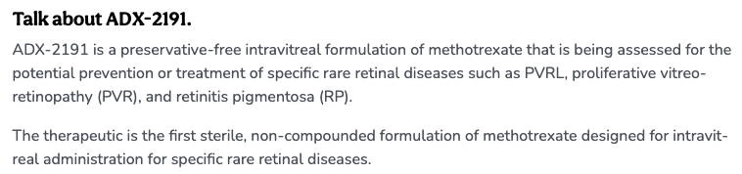





<https://glance.eyesoneyecare.com/stories/2023-11-28/aldeyra-s-nda-for-reproxalap-requires-more-studies-fda-says/?utm_medium=eoe:infinite-scroll>

